**Project Design Phase-II**

**Data Flow Diagram &User Stories**

|  |  |
| --- | --- |
| Date | 20October 2022 |
| Team ID | PNT2022TMID43503 |
| Project Name | Natural Disasters Intensity Analysis and  Classification using Artificial Intelligence |

**Data Flow Diagrams:**

A Data Flow Diagram (DFD) is a traditional visual representation of the information flows within a system. A neat and clear DFD can depict the right amount of the system requirement graphically. It shows how data enters and leaves the system, what changes the information, and where data is stored.

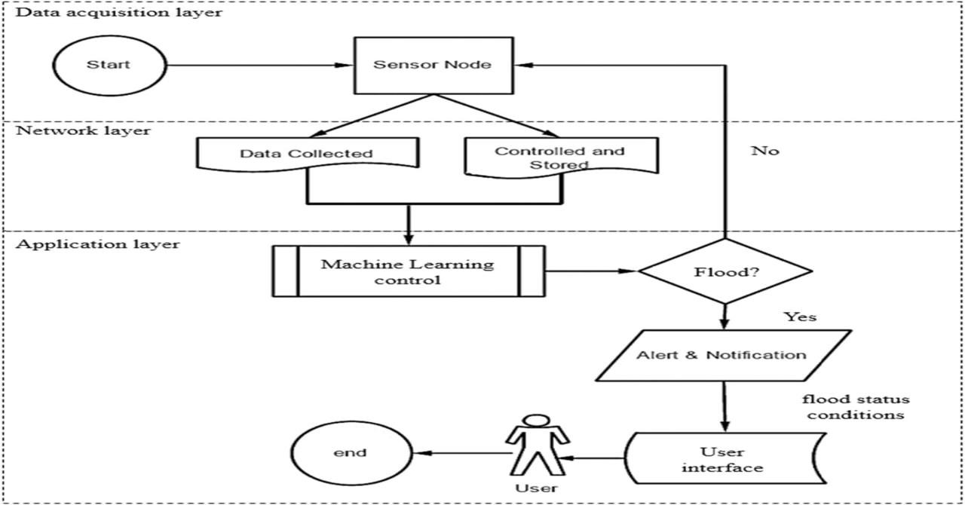

**User Stories**

Use the below template to list all the user stories for the product.

|  |  |  |  |  |  |
| --- | --- | --- | --- | --- | --- |
| **User Type** | **Functional**  **Requirement (Epic)** | **User**  **Story**  **Number** | **User Story / Task** | **Acceptance criteria** | **Priority** |
| Customer  (Professional) | Remote Sensing | USN-1 | As a user, I can find a method more efficient and advanced. | I can visualize the critical vulnerabilities & damages. | High |
|  | Physical Features | USN-2 | As a user, I can find it gathering information and tracking. | I can collect the information from affected areas and track the people who are affected. | High |
|  | Security | USN-3 | As a user, I can provide useful information to decision-makers, helping to establish global peace and security. | I can reach near real time insights at the ground level. | Low |
|  | Results | USN-4 | As a user, I can rely on the results without any suspicion. | The technique is almost 100% efficient as it involves Modern | Medium |
| **User Type** | **Functional**  **Requirement (Epic)** | **User**  **Story**  **Number** | **User Story / Task** | **Acceptance criteria** | **Priority** |
|  |  |  |  | techniques incorporated with Machine Learning |  |
|  |  | USN-5 | As a user, I can get the results on the spot immediately after the sensing. | It prevents further delay in the risk identification and warning. | High |
| Customer  (Affected  People) | Safety | USN-6 | As a user,I may not enter the damaged buildings or home. | I will not enter into the damaged buildings because floodwaters remain around the building and Authorities have not declared it safe to enter. | High |
| Customer  (Public  Sector) | Cost effectiveness | USN-7 | As a user,I can reach many people suffering from no food and shelter. | I will rescue the affected people and increase the national insurance resilence. | Medium |
|  | Results | USN-8 | As a user, I can complete the sensing process within minute for an affected people. | The random results generated by the device saves people and time. | High |